**Master Functional Document**

|  |  |
| --- | --- |
| **Application** | NGERP - Centra |
| **Service Bundle** | Master Management |
| **Service Request** | NTA AP Invoice Confirm |

**Description :**

NTA AP Invoice Confirm screen is used to complete the NTA AP Invoice.

**Workflow Process :**

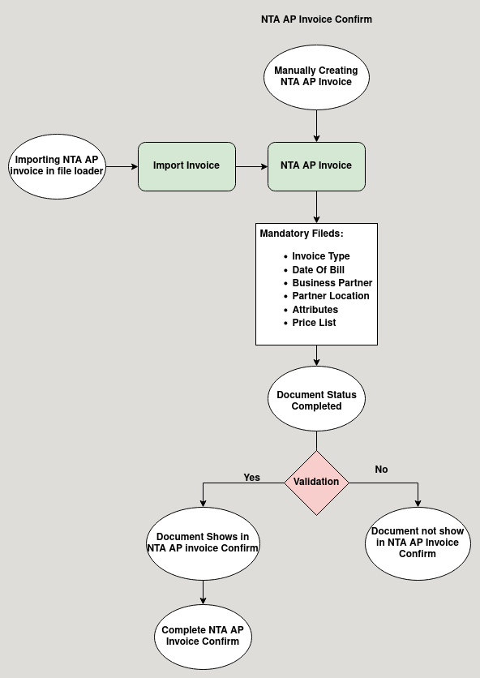

**Business Rules :**

* NTA AP Invoice Screen only Show in HQ.
* This Screen is used to complete NTA AP Invoice .
* There are two ways to do the NTA AP Invoice:
  + Import
  + Manual
* The first method is to import the invoice using file loader in HQ.
* The import Format is 3A NTA AP invoice.
* The imported file will be show in import invoice screen, from their the user should click import invoice to import the NTA AP Invoice to NTA AP Invoice screen.
* The second method is to manually create the NTA AP invoice in the NTA AP invoice screen.
* The user Should fill the mandatory field listed below to complete the NTA AP Invoice
  + Invoice Type
  + Date of Bill
  + Business Partner
  + Partner Location
  + Attributes
  + Price List
* After Adding lines in NTA AP Invoice click Complete to prepare the document.
* To complete the document go to NTA AP Invoice Confirm Screen.
* Click Complete to complete the NTA AP Invoice.